SOFTWARE DESIGN

S3-INDIVUDUAL

Welles,Nick N.H.M.

2022 - 2023

Inhoudsopgave

User stories 2

Concept diagram 3

Software architecture 4

System context diagram 4

Container diagram (Web shop system) 4

Component diagram (API) 5

Component diagram (Single page) 5

# User stories

Here are a number of user stories that have been formulated to help me verify the functionality of the Instruweb application. The user stories are in a table which are numbered by functional- and non-functional requirements.

**FR** stands for functional requirement.  
**NF** stands for non-functional requirement.

|  |  |
| --- | --- |
|  | Functional |
| FR-01 | As a user I want to be able to select categories so I can find a potential desired product(s). |
| FR-02 | As a user I want to be able to add one or multiple items to my shopping cart so I can order my desired products. |
| FR-03 | As a user, I want to be able to easily remove one or more products from my shopping cart. |
| FR-04 | As a user, I want to be able to create an account so that my data is saved for a subsequent order. |
| FR-05 | As an administrator, I want to be able to easily create user and administrator accounts so that selecting roles remains under administrators. |
| FR-06 | As an administrator, I want to be able to modify products in the web shop so that the information and price remain up-to-date. |
| FR-07 | As a user, I want to be able to check out the products in my cart so that the order is initiated. |
| FR-08 | As a user, I want to be able to update my account information so that my information can be kept up-to-date. |
| FR-09 | As a user, I want to be able to search for products all over the site so that I can find my desired product. |
| FR-10 | As a user, I want to be able to filter by certain characteristics in the selected category so that I can more easily find the product I am looking for. |
| FR-11 | As a user, I want to see related products on the product page so that I can order something with them if necessary. |
| FR-12 | As a developer, I want a product to be able to contain multiple categories so that searching for particular products is simplified. |
| FR-13 | As a user, I want to be able to log in so I can update my account information. |
| FR-14 | As a user, I want to be able to register so I can update my account information. |

|  |  |
| --- | --- |
|  | Non-functional |
| NF-01 | As a user I want to be able to view the website on every device whenever I want so I can purchase products everywhere. |
| NF-02 | As a software developer I want the application to be maintainable and scalable so I can add functionality to it in the future. |
| NF-03 | As a software developer I want the front-end and backend communicating via an API. |
| NF-04 | As a user I want the website to load within 1 seconds so I won’t visit another website. |

# Concept diagram

To make it easier on myself, I took a chart from semester 2 into this. The concept diagram contains simple entities which I have all given a property. For me, this clarifies the picture of how I can possibly build another diagram (think ERD, ERM etc) to then make my project more complete.

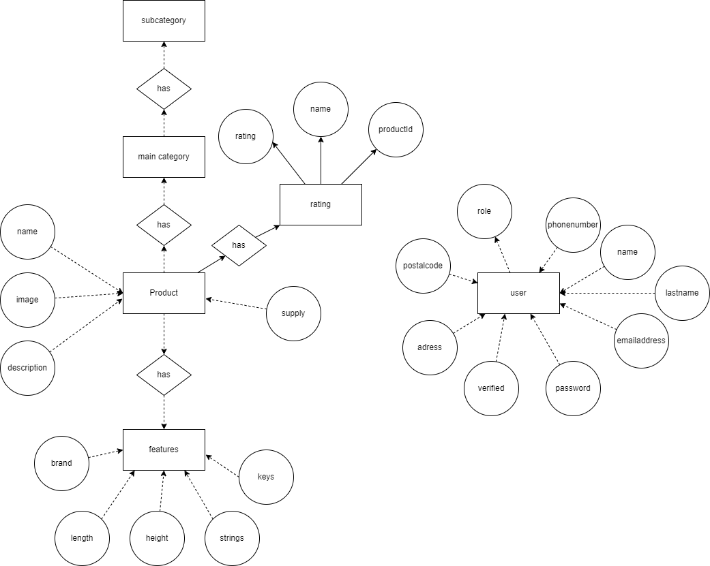

In a web shop the most important entities are the user and the product. The product contains all the information to make it easy to search one or select one via the categories the product has. The user can register for an account so they don’t have to fill in their billing information again since their information will be saved.

Since this is a concept diagram it has never really been completely finished.

# Software architecture

## System context diagram

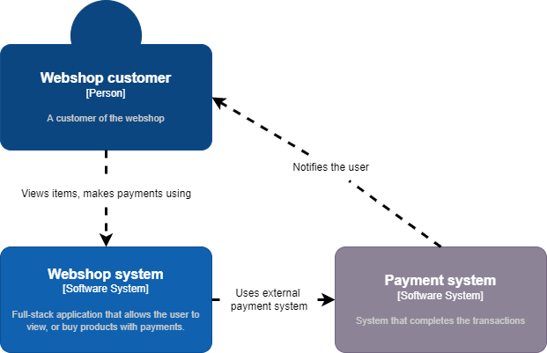

## Container diagram (Web shop system)

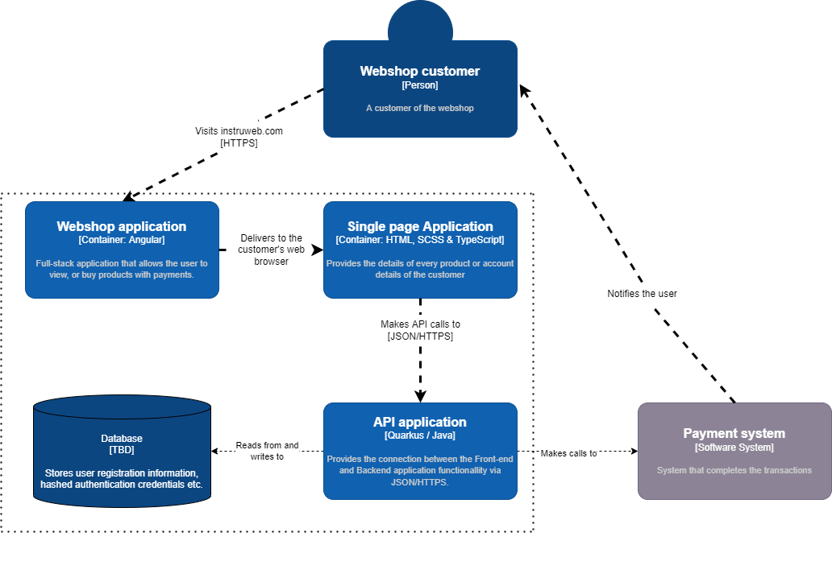

## Component diagram (API)

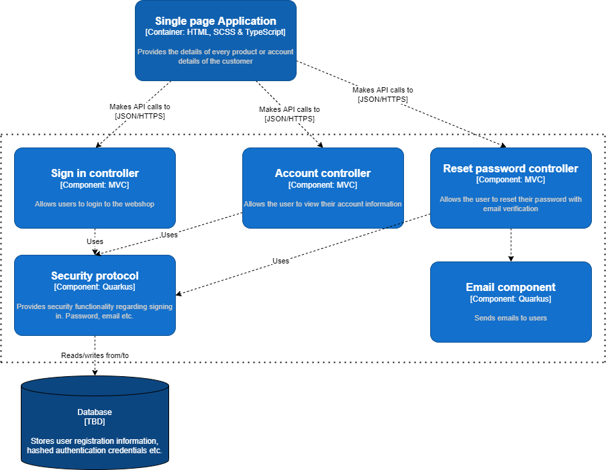

## Component diagram (Single page)

